FLEET BRIDGE

BRIDGE

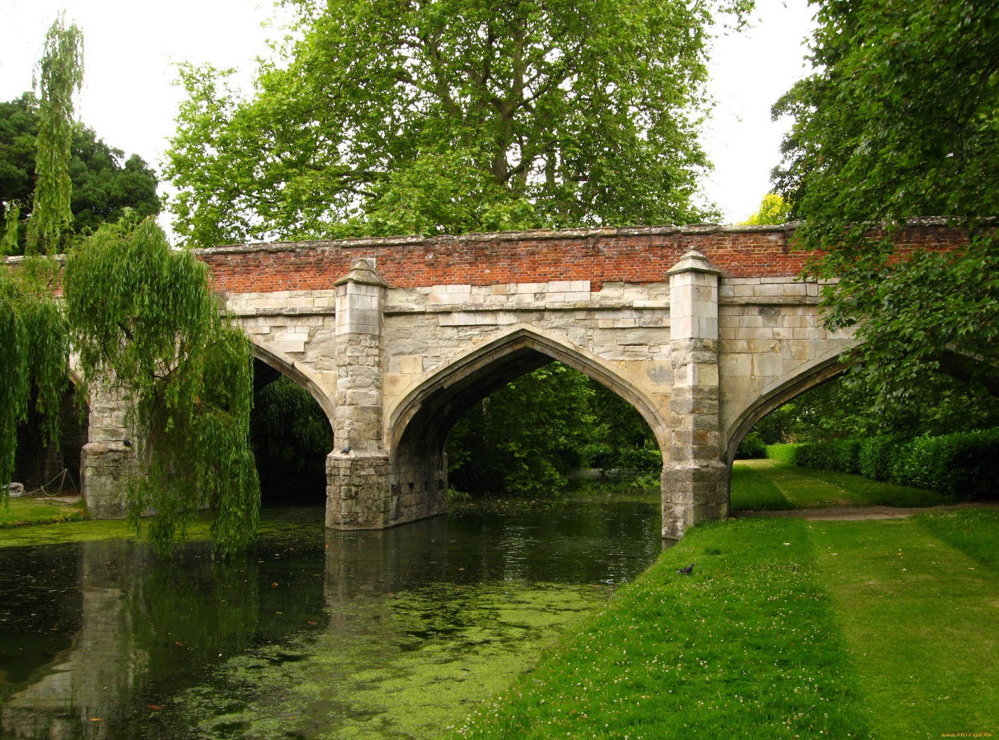

Fleet Bridge, an integral part of London's historic landscape, stands as a testament to the city's rich heritage and architectural legacy. Spanning the River Fleet in the heart of the capital, this iconic bridge has been a vital thoroughfare for centuries, connecting the bustling neighborhoods of Holborn and Black friars. While the current bridge dates back to the 1860s, it sits on the site of earlier crossings that have existed since Roman times, making it a focal point of London's ancient road network.

Constructed of sturdy stone masonry and elegant ironwork, Fleet Bridge boasts a timeless aesthetic that blends seamlessly with its surroundings. Its graceful arches and ornate detailing pay homage to the Victorian era, while its robust structure speaks to the enduring craftsmanship of its builders. As pedestrians, cyclists, and vehicles traverse its span, they are greeted by panoramic views of the River Fleet below and the historic landmarks that line its banks, including St. Bride's Church and the iconic dome of St. Paul's Cathedral.

Beyond its practical function as a transportation artery, Fleet Bridge holds significant cultural and historical significance for the city of London. It has witnessed centuries of change and upheaval, from the bustling markets and bustling traffic of medieval times to the industrial revolution and modernization of the 19th century.